- EMRAH YAYLA

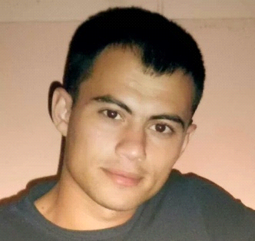

Marital status: Single
Date of birth: 06.06.1987
Nationalty: Republic of Turkey
Contact adress: Osmangazi mahallesi
Kanuni caddesi 1884. sokak no:13 KIRIKKALE/Merkez
Mobile: 00905539866699
Whatsapp: 00905385587208
Email: emrahyayla4071@gmail.com
Education background: 17 Ağustos lisesi

EXPERİENCE

-07.02.2008-25.01.2012 BEKA PROJE/TÜPRAŞ RAFİNERY PROJECT/TURKEY I worked as a welder.

-14.02.2012-10.07.2012 MPE/KARABÜK WATER TREATMENT PROJECT/TURKEY I worked as a welder.

-11.09.2012-24.12.2012 ETA ENERJİ/ MODERN CARDBOARD FACTORY REVİSİON PROJECT/TURKEY I worked as a welder.

-05.01.2013-22.09.2013 GEMONT/TÜPRAŞ RESİDUUM UPGRADİNG PROJECT/TURKEY I worked as a welder.

-10.10.2013-29.05.2015 HYDRA-ARC/SKYHİLL WORKSHOP-SASOL RAFİNERY REVİSİON PROJECT/SOUTH AFRİCA I worked as a welder.

-02.10.2015-14.01.2016 GAMA NATURAL GAS CONVERSİON PLANT PROJECT/TURKEY I worked as a welder.

-02.02.2016-15.062016 BİMSAN/SOCAR STAR RAFİNERY PROJECT/TURKEY I worked as a welder.

-18.06.2016-23.09.2016 GEMONT/SOCAR STAR RAFİNERY PROJECT/TURKEY I worked as a welder.

-26.09.2016-27.01.2017 BİMSAN/BİMSAN WORKSHOP/TURKEY I worked as a welder.

-14.02.2017-05.06.2017 TEKNOKON/ANAGOLD/TURKEY I worked as a welder.

-06.07.2017-02.07.2018 ŞENLİKOĞLU/QATAR I worked as a inspector.

-12.03.2019-31.05.2019 AGT/SİMETRİK MÜHENDİSLİK I worked
as a inspector.

-19.10.2019-05.09.2020 EFOR ENDÜSTRİYEL WORKSHOP I worked as a inspector.

-07.09.2020-23.10.2020 BORENTEK INŞAAT TUZ GÖLÜ UNDERGROUND GAS PROJECT I worked as a welder.

OTHER SKİLS

-Know Isometry
-Pipe assembly
-I have CSWIP 3.1 inspector certificate

INTERESTS

-Football
-Music
-Fishing
-Hiking

COMMENTARY

I have many projects, I have a lot of experince. So I have self confidence. I'm good person in team work. I'm a very harmonious person. I know english in middle level.

